1. URL for blog app and its screenshots are listed below :

<http://localhost:8000/myblogapp/landing/>

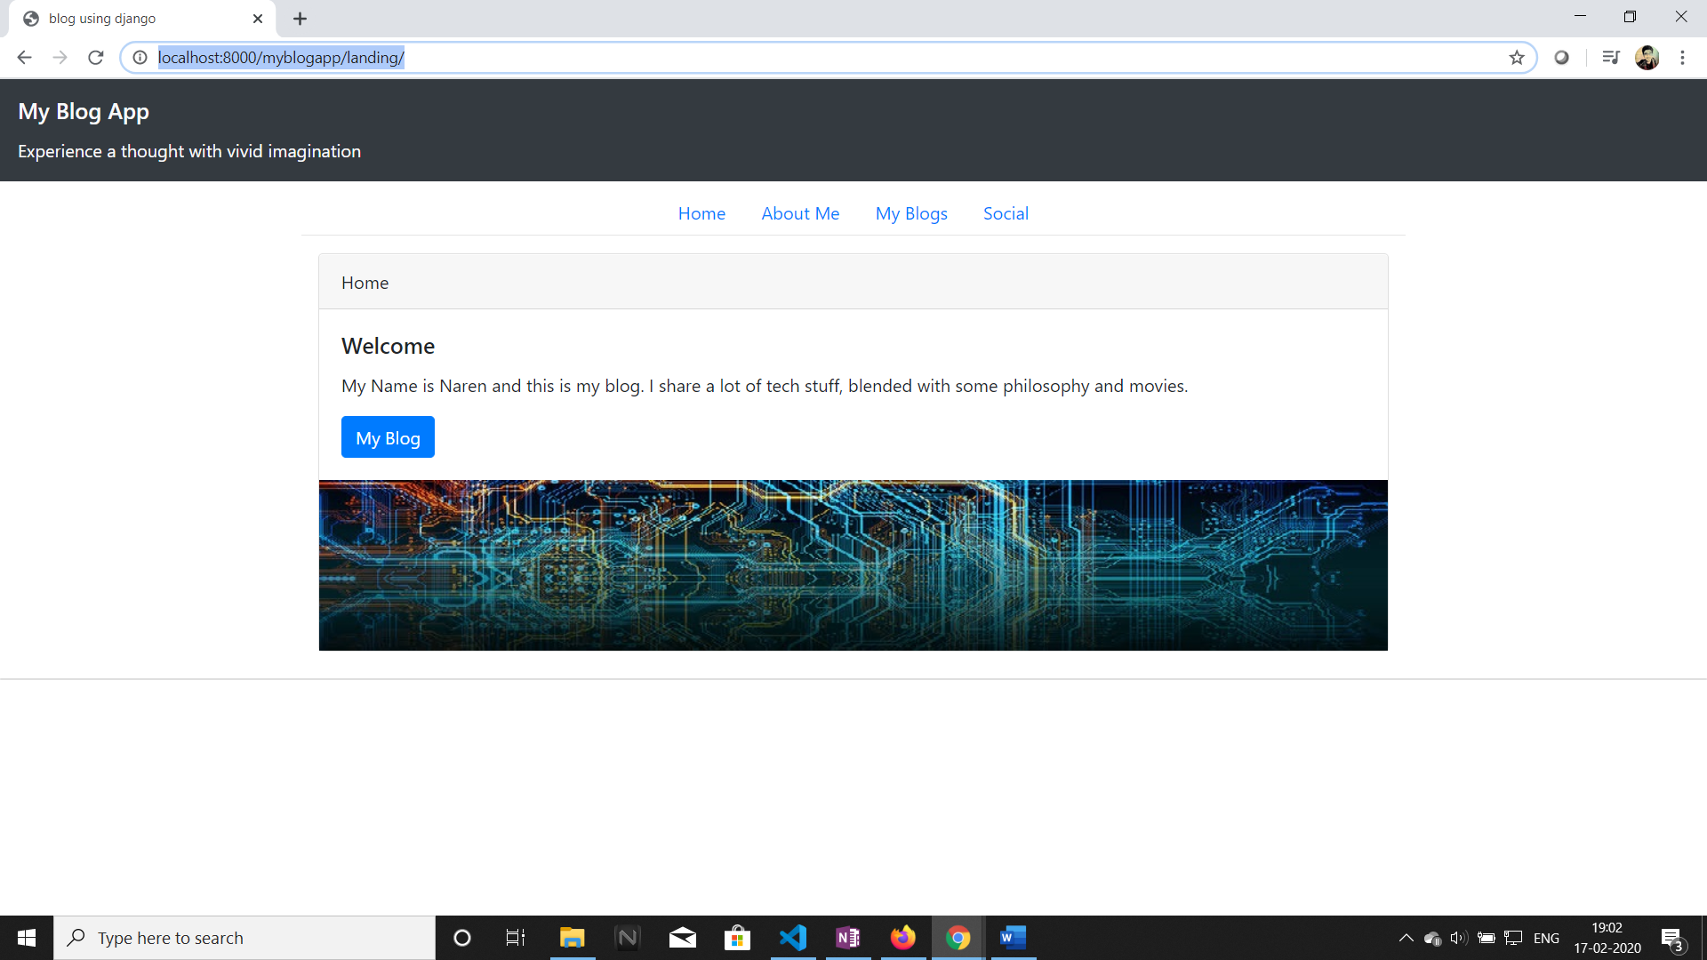

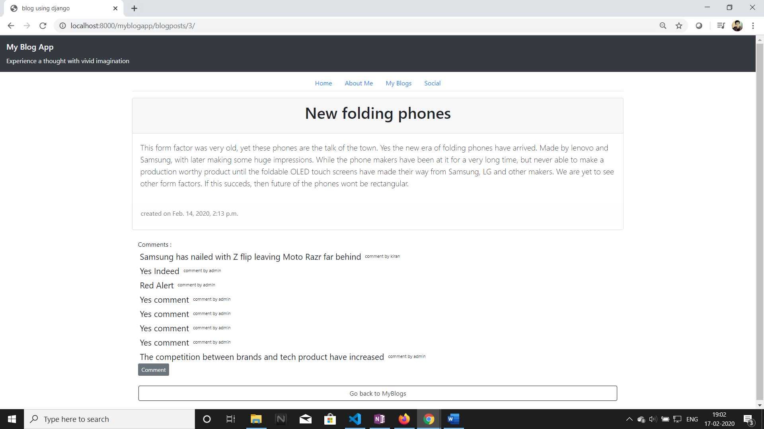

1. URL for polls app and its screenshots are listed below :

<http://localhost:8000/polls/>

